**Supplementary Figure 1. Flow chart of the analyses.**

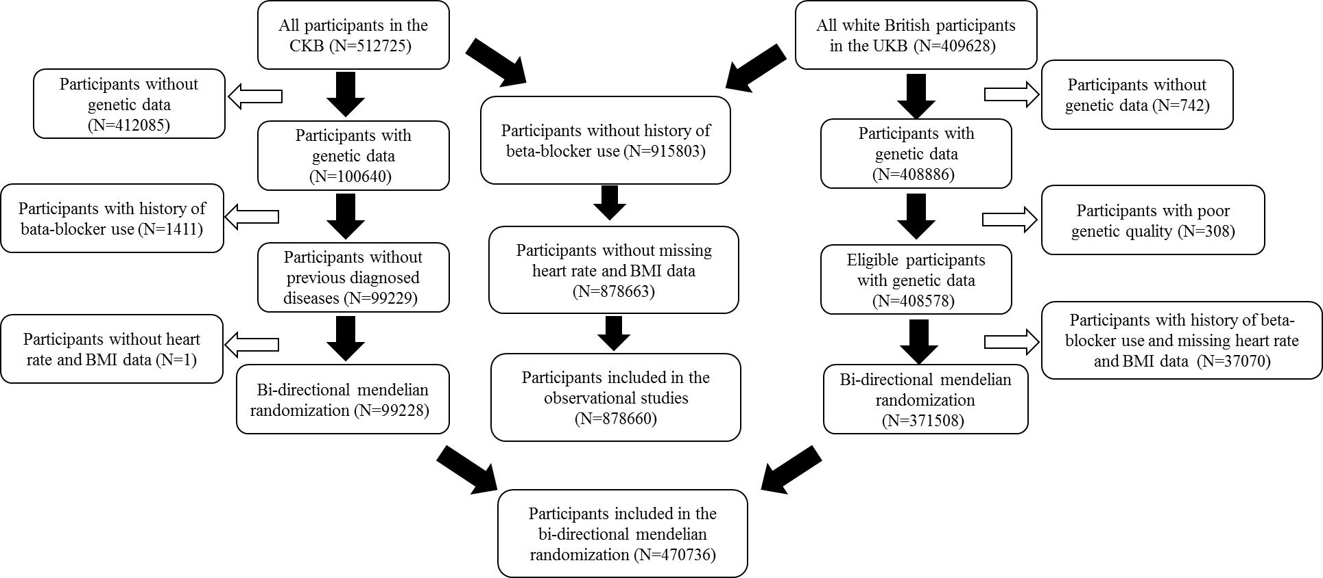

**Supplementary Figure 2. Distribution of resting heart rate and resting heart rate genetic risk score in the UKB and CKB cohort.**

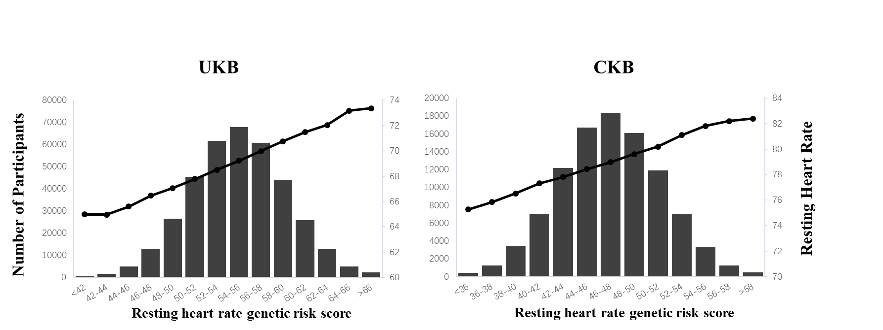

UKB, UK Biobank; CKB, China Kadoorie Biobank.

**Supplementary Figure 3. Observational analysis of quintile of resting heart rate are associated with cardiometabolic traits in the UKB and CKB.**

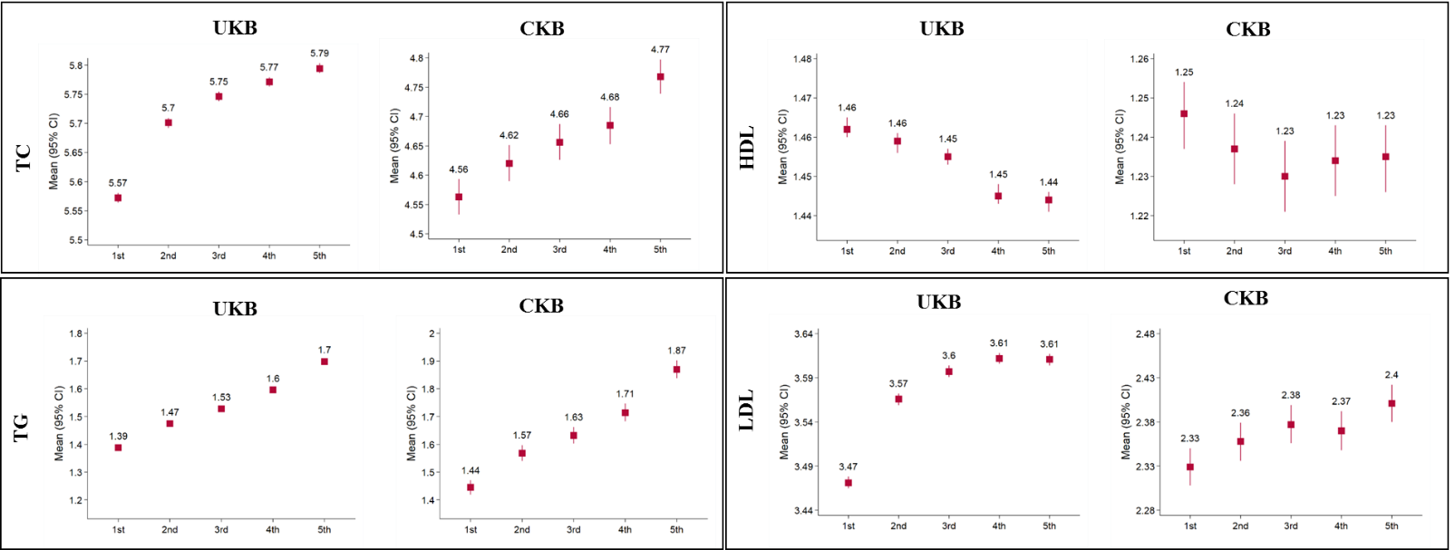

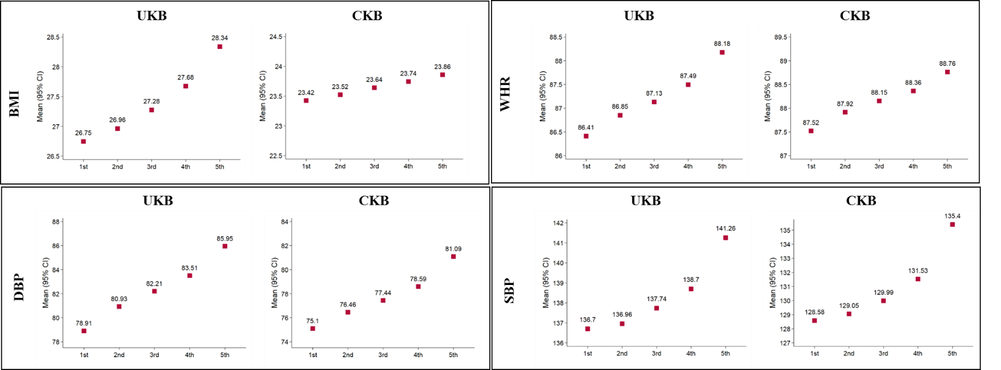

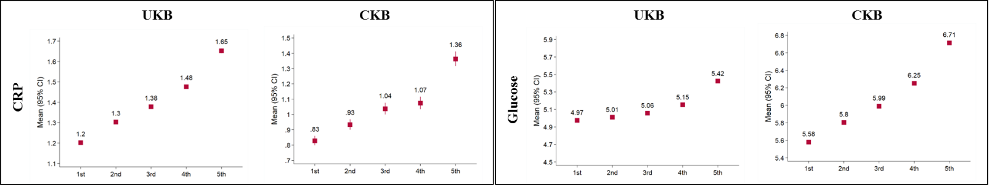

Estimated marginal means of cardiometabolic traits, from general linear model analysis adjusted for sex, age, BMI (except for BMI), household income, education level, Townsend Deprivation Index (only for UKB), marital status (only for CKB), region code (only for CKB), smoking status, alcohol intake frequency, intake of fruit and vegetable, self-reported health status, and metabolic equivalent (MET) are presented according to quintiles of resting heart rate. TC, total cholesterol; HDL, high density lipoprotein; LDL, low density lipoprotein; TG, triglyceride; BMI, body mass index; WHR, waist-hip ratio; DBP, diastolic blood pressure; SBP, systolic blood pressure; CRP: C-reactive protein; UKB, UK Biobank; CKB, China Kadoorie Biobank.

**Supplementary Figure 4. Mendelian randomization analysis of quintile of resting heart rate are associated with cardiometabolic traits in the UKB and CKB.**

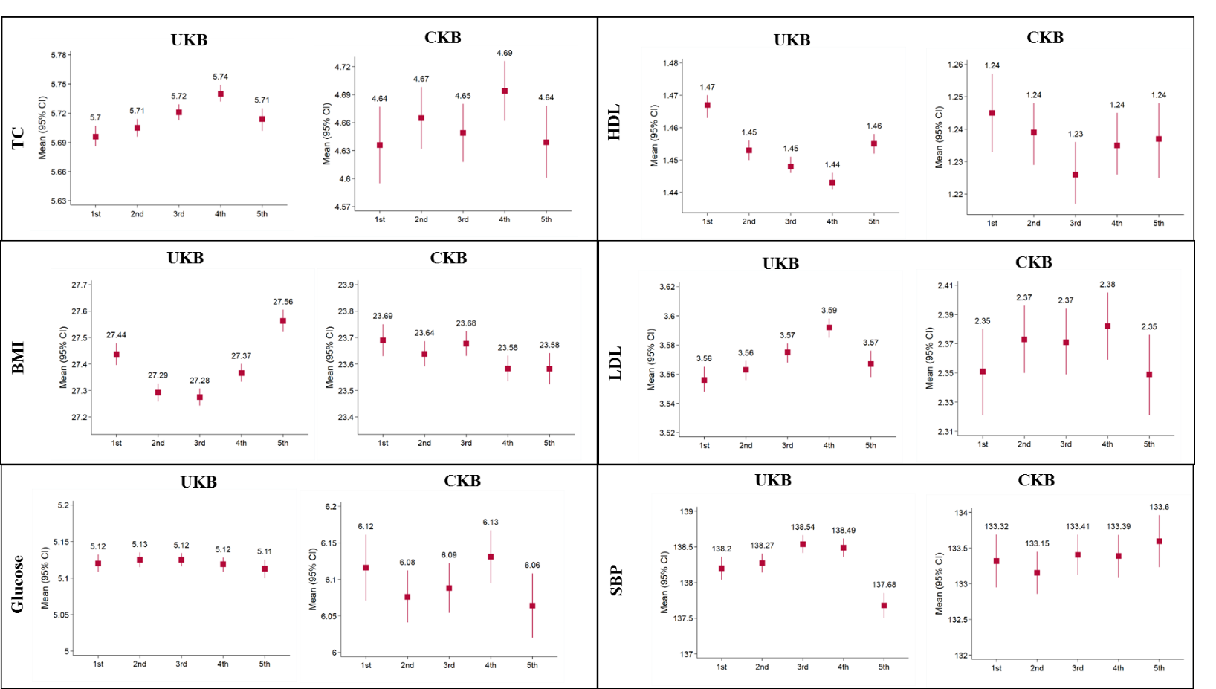

Estimated marginal means of resting heart rate, from general linear model analysis adjusted for sex, age, BMI (except for BMI), household income, education level, Townsend Deprivation Index (only for UKB), marital status (only for CKB), region code (only for CKB), smoking status, alcohol intake frequency, intake of fruit and vegetable, self-reported health status, and metabolic equivalent (MET) are presented according to quintiles of cardiometabolic traits. TC, total cholesterol; HDL, high density lipoprotein; LDL, low density lipoprotein; TG, triglyceride; BMI, body mass index; WHR, waist-hip ratio; DBP, diastolic blood pressure; SBP, systolic blood pressure; CRP: C-reactive protein; UKB, UK Biobank; CKB, China Kadoorie Biobank.

**Supplementary Figure 5. Reverse mendelian randomization analysis of quintile of cardiometabolic traits are associated with resting heart rate in the UKB and CKB.**

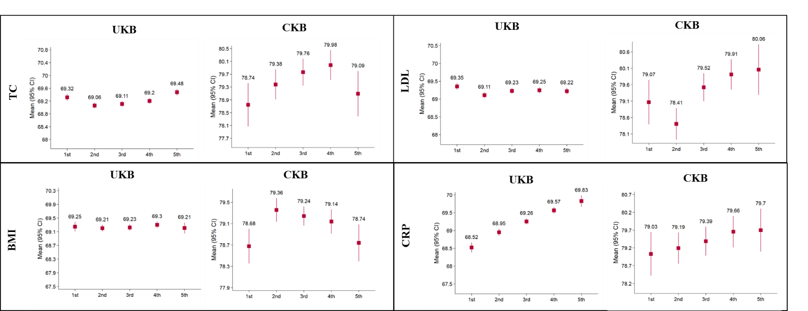

Estimated marginal means of resting heart rate, from general linear model analysis adjusted for sex, age, BMI (except for BMI), household income, education level, Townsend Deprivation Index (only for UKB), marital status (only for CKB), region code (only for CKB), smoking status, alcohol intake frequency, intake of fruit and vegetable, self-reported health status, and metabolic equivalent (MET) are presented according to quintiles of cardiometabolic traits. TC, total cholesterol; HDL, high density lipoprotein; LDL, low density lipoprotein; TG, triglyceride; BMI, body mass index; WHR, waist-hip ratio; DBP, diastolic blood pressure; SBP, systolic blood pressure; CRP: C-reactive protein; UKB, UK Biobank; CKB, China Kadoorie Biobank.

|  |  |  |  |  |  |  |
| --- | --- | --- | --- | --- | --- | --- |
| STable 2. Baseline characteristics of the study participants according to the quintile of weighted heart rate genetic risk score (HR_GRS_W) in the UKB. | | | | | | |
| Characteristic | Q1 | Q2 | Q3 | Q4 | Q5 | P-value* |
| N | 74,981 | 76,848 | 74,417 | 72,002 | 73,260 |  |
| HR_GRS_W | 36.1-51.2 | 51.3-53.8 | 53.9-56 | 56.1-58.5 | 58.6-75 |  |
| Age, yr | 56.96 (7.99) | 56.93 (8.00) | 56.93 (7.99) | 56.87 (8.01) | 56.94 (7.99) | 0.238 |
| Male | 34,546 (46.07) | 35,454 (46.14) | 34,209 (45.97) | 33,338 (46.30) | 33,569 (45.82) | 0.435 |
| Heart rate, bpm | 67.0` (10.94) | 68.38 (11.11) | 69.25 (11.16) | 70.12 (11.14) | 71.53 (11.39) | <0.001 |
| BMI, kg/m2 | 27.38 (4.73) | 27.36 (4.69) | 27.40 (4.72) | 27.41 (4.74) | 27.38 (4.72) | 0.433 |
| MET, minutes/week | 2,674 (2462) | 2,671 (2458) | 2,683 (2464) | 2,675 (2450) | 2,673 (2436) | 0.953 |
| University/college degree or above | 22,857 (30.48) | 23,439 (30.50) | 22,853 (30.71) | 22,073 (30.66) | 22,515 (30.73) | 0.748 |
| Current weekly drinkers | 54,165 (72.24) | 55,404 (72.10) | 53,474 (71.86) | 51,613 (71.68) | 52,475 (71.63) | 0.038 |
| Current smoker | 7,380 (9.84) | 7,709 (10.03) | 7,379 (9.92) | 7,235 (10.05) | 7,344 (10.02) | 0.616 |
| Household income |  |  |  |  |  | 0.863 |
| Less than 18,000 | 14,438 (19.26) | 14,783 (19.24) | 14,198 (19.08) | 13,655 (18.96) | 14,028 (19.15) |  |
| 18,000 to 30,999 | 23,574 (31.44) | 24,112 (31.38) | 23,402 (31.45) | 22,717 (31.55) | 22,970 (31.35) |  |
| 31,000 to 51,999 | 20,479 (27.31) | 20,966 (27.28) | 20,387 (27.40) | 19,819 (27.53) | 20,125 (27.47) |  |
| 52,000 to 100,000 | 13,136 (17.52) | 13,555 (17.64) | 12,997 (17.47) | 12,654 (17.57) | 12,794 (17.46) |  |
| Greater than 100,000 | 3,354 (4.47) | 3,432 (4.47) | 3,433 (4.61) | 3,157 (4.38) | 3,343 (4.56) |  |
| Self-reported health |  |  |  |  |  | 0.042 |
| Excellent | 12,540 (16.72) | 12,782 (16.63) | 12,067 (16.22) | 11,919 (16.55) | 11,908 (16.25) |  |
| Good | 44,259 (59.03) | 45,170 (58.78) | 44,191 (59.38) | 42,223 (58.64) | 43,266 (59.06) |  |
| Fair | 15,163 (20.22) | 15,776 (20.53) | 15,065 (20.24) | 14,859 (20.64) | 15,057 (20.55) |  |
| Poor | 3,019 (4.03) | 3,120 (4.06) | 3,094 (4.16) | 3,001 (4.2) | 3,029 (4.13) |  |
| Fruit intake, pieces/d | 2.98 (2.49) | 2.94 (2.42) | 2.96 (2.51) | 2.94 (2.46) | 2.95 (2.47) | 0.129 |
| Vegetable intake, tablespoons/d | 4.78 (2.99) | 4.78 (3.04) | 4.78 (3.11) | 4.77 (3.07) | 4.80 (3.10) | 0.257 |
| * P-values computed via ANOVA for continuous variables and chi-square test for categorical variables.  ** All values are indicated in means (S.D) or number (percentages). | | | | |  |  |

|  |  |  |  |  |  |  |
| --- | --- | --- | --- | --- | --- | --- |
| STable 3. Baseline characteristics of the study participants according to the quintile of weighted heart rate genetic risk score (HR_GRS_W) in the CKB. | | | | | | |
| Characteristic | Q1 | Q2 | Q3 | Q4 | Q5 | P-value* |
| N | 20,441 | 20,051 | 19,240 | 20,060 | 19,436 |  |
| HR_GRS_W | 28.1-43.3 | 43.4-45.8 | 45.9-47.9 | 48-50.5 | 50.6-65.8 |  |
| Age, yr | 53.65 (11.07) | 53.74 (10.99) | 53.60 (10.94) | 53.49 (10.99) | 53.58 (11.01) | 0.115 |
| Male | 8,779 (42.95) | 8,612 (42.95) | 8,255 (42.91) | 8,553 (42.64) | 8,241 (42.40) | 0.754 |
| Heart rate, bpm | 77.22 (11.77) | 78.34 (11.85) | 78.97 (11.86) | 79.73 (11.90) | 80.99 (11.95) | <0.001 |
| BMI, kg/m2 | 23.66 (3.52) | 23.70 (3.49) | 23.61 (3.45) | 23.64 (3.49) | 23.56 (3.47) | <0.001 |
| MET, minutes/week | 19.91 (13.78) | 19.96 (13.83) | 20.03 (13.84) | 19.94 (13.70) | 19.95 (13.81) | 0.840 |
| University/college degree or above | 1,210 (5.92) | 1,200 (5.98) | 1,140 (5.93) | 1,182 (5.89) | 1,109 (5.71) | 0.811 |
| Current weekly drinkers | 3,254 (15.92) | 3,106 (15.49) | 2,980 (15.49) | 3,041 (15.16) | 2,972 (15.29) | 0.276 |
| Current smoker | 5,688 (27.83) | 5,570 (27.78) | 5,326 (27.68) | 5,515 (27.49) | 5,300 (27.27) | 0.720 |
| Urban | 8,744 (42.78) | 8,823 (44.00) | 8,326 (43.27) | 8,642 (43.08) | 8,540 (43.94) | 0.051 |
| Married | 18,214 (89.11) | 17,915 (89.35) | 17,220 (89.50) | 17,896 (89.21) | 17,297 (88.99) | 0.522 |
| Household income |  |  |  |  |  | 0.127 |
| Less than 10,000 | 6,502 (31.83) | 6,212 (30.98) | 5,936 (30.85) | 6,200 (30.91) | 6,057 (31.16) |  |
| 10,000 to 19,999 | 6,167 (30.17) | 6,029 (30.07) | 5,739 (29.83) | 6,054 (30.18) | 5,808 (29.88) |  |
| 20,000 to 34,999 | 4,605 (22.53) | 4,603 (22.96) | 4,572 (23.76) | 4,545 (22.66) | 4,478 (23.04) |  |
| Greater than 35,000 | 3,167 (15.49) | 3,207 (15.99) | 2,993 (15.56) | 3,261 (16.26) | 3,093 (15.91) |  |
| Self-reported health |  |  |  |  |  | 0.708 |
| Excellent | 3,502 (17.13) | 3,466 (17.29) | 3,293 (17.12) | 3,419 (17.04) | 3,348 (17.23) |  |
| Good | 5,548 (27.14) | 5,495 (27.41) | 5,160 (26.82) | 5,465 (27.24) | 5,307 (27.31) |  |
| Fair | 9,004 (44.05) | 8,774 (43.76) | 8,627 (44.84) | 8,877 (44.25) | 8,629 (44.40) |  |
| Poor | 2,387 (11.68) | 2,316 (11.55) | 2,160 (11.23) | 2,299 (11.46) | 2,152 (11.07) |  |
| Fruit intake |  |  |  |  |  | 0.034 |
| Daily | 3,908 (19.12) | 3,891 (19.41) | 3,690 (19.18) | 3,728 (18.58) | 3,587 (18.46) |  |
| 4-6 days per week | 1,782 (8.72) | 1,852 (9.24) | 1,650 (8.58) | 1,811 (9.03) | 1,797 (9.25) |  |
| 1-3 days per week | 6,371 (31.17) | 6,076 (30.30) | 6,063 (31.51) | 6,294 (31.38) | 6,204 (31.92) |  |
| Monthly | 6,912 (33.81) | 6,811 (33.97) | 6,476 (33.66) | 6,764 (33.72) | 6,516 (33.53) |  |
| Vegetable intake |  |  |  |  |  | 0.902 |
|  |  |  |  |  |  |  |
| Characteristic | Q1 | Q2 | Q3 | Q4 | Q5 | P-value* |
| Daily | 19,287 (94.35) | 18,975 (94.63) | 18,172 (94.45) | 18,993 (94.68) | 18,402 (94.68) |  |
| 4-6 days per week | 788 (3.90) | 731 (3.65) | 751 (3.9\0) | 745 (3.71) | 733 (3.77) |  |
| 1-3 days per week | 287 (1.40) | 284 (1.42) | 261 (1.36) | 267 (1.33) | 246 (1.27) |  |
| Monthly | 64 (0.31) | 56 (0.28) | 50 (0.26) | 53 (0.26) | 49 (0.25) |  |
| * P-values computed via ANOVA for continuous variables and chi-square test for categorical variables.  ** All values are indicated in means (S.D) or number (percentages). | | | | |  |  |

|  |  |  |  |  |  |
| --- | --- | --- | --- | --- | --- |
| STable 4. Effects of resting heart rate (per 10 bpm) on cardiometabolic traits (1 unit higher) in observational and Mendelian analyses. | | | | | |
| Traits | CKB | |  | UKB | |
| Beta (95%CI) | P |  | Beta (95%CI) | P |
| TC, mmol / L |  |  |  |  |  |
| Observational analyses | 0.063 (0.051, 0.075) | <0.001 |  | 0.068 (0.064, 0.072) | <0.001 |
| Mendelian randomization | 0.056 (-0.046, 0.158) | 0.280 |  | 0.004 (-0.020, 0.028) | 0.743 |
| TG (log), mmol / L |  |  |  |  |  |
| Observational analyses | 0.075 (0.069, 0.081) | <0.001 |  | 0.062 (0.060, 0.064) | <0.001 |
| Mendelian randomization | 0.052 (-0.009, 0.113) | 0.091 |  | 0.020 (0.010, 0.030) | <0.001 |
| HDL, mmol / L |  |  |  |  |  |
| Observational analyses | -0.001 (-0.005, 0.003) | 0.433 |  | -0.005 (-0.007, -0.003) | <0.001 |
| Mendelian randomization | 0.004 (-0.025, 0.033) | 0.778 |  | 0.007 (-0.001, 0.015) | 0.048 |
| LDL, mmol / L |  |  |  |  |  |
| Observational analyses | 0.021 (0.013, 0.029) | <0.001 |  | 0.041 (0.039, 0.043) | <0.001 |
| Mendelian randomization | 0.024 (-0.049, 0.097) | 0.521 |  | -0.010 (-0.028, 0.008) | 0.277 |
| CRP (log), mg / L |  |  |  |  |  |
| Observational analyses | 0.149 (0.135, 0.163) | <0.001 |  | 0.099 (0.097, 0.101) | <0.001 |
| Mendelian randomization | 0.180 (0.057, 0.303) | 0.004 |  | 0.154 (0.134, 0.174) | <0.001 |
| GLU, mmol / L |  |  |  |  |  |
| Observational analyses | 0.348 (0.342, 0.354) | <0.001 |  | 0.152 (0.148, 0.156) | <0.001 |
| Mendelian randomization | -0.032 (-0.146, 0.082) | 0.585 |  | -0.006 (-0.031, 0.019) | 0.621 |
| BMI, kg / m2 |  |  |  |  |  |
| Observational analyses | 0.123 (0.115, 0.131) | <0.001 |  | 0.681 (0.667, 0.695) | <0.001 |
| Mendelian randomization | -0.205 (-0.358, -0.052) | 0.009 |  | -0.006 (-0.096, 0.084) | 0.896 |
| WHR, % |  |  |  |  |  |
| Observational analyses | 0.364 (0.352, 0.376) | <0.001 |  | 0.555 (0.539, 0.571) | <0.001 |
| Mendelian randomization | 0.218 (-0.033, 0.469) | 0.090 |  | 0.225 (0.111, 0.339) | <0.001 |
| SBP, mmHg |  |  |  |  |  |
| Observational analyses | 2.186 (2.143, 2.229) | <0.001 |  | 1.542 (1.491, 1.593) | <0.001 |
| Mendelian randomization | 0.571 (-0.366, 1.508) | 0.233 |  | -1.154 (-1.497, -0.811) | <0.001 |
| DBP, mmHg |  |  |  |  |  |
| Observational analyses | 1.860 (1.836, 1.884) | <0.001 |  | 2.258 (2.231, 2.285) | <0.001 |
| Mendelian randomization | 2.059 (1.544, 2.574) | <0.001 |  | 2.037 (1.845, 2.229) | <0.001 |

The adjusted effect size from general linear model for cardiometabolic traits, according to observed or genetically-predicted resting heart rate in CKB and UKB, of which 1 unit of cardiometabolic traits per 10 bpm higher resting heart rate. Estimated effect of cardiometabolic traits, from general linear model analysis adjusted for sex, age, BMI (except for BMI), household income, education level, Townsend Deprivation Index (only for UKB), marital status (only for CKB), region code (only for CKB), smoking status, alcohol intake frequency, intake of fruit and vegetable, self-reported health status, and metabolic equivalent (MET). TC, total cholesterol; HDL, high density lipoprotein; LDL, low density lipoprotein; TG, triglyceride; BMI, body mass index; WHR, waist-hip ratio; DBP, diastolic blood pressure; SBP, systolic blood pressure; CRP: C-reactive protein; UKB, UK Biobank; CKB, China Kadoorie Biobank.

|  |  |  |  |  |  |
| --- | --- | --- | --- | --- | --- |
| STable 5. Effects of cardiometabolic traits (1 unit higher) on resting heart rate in observational and Mendelian analyses. | | | | | |
| Traits | CKB | |  | UKB | |
| Beta (SE) | P |  | Beta (SE) | P |
| TC, mmol / L |  |  |  |  |  |
| Observational analyses | 1.094 (0.901, 1.286) | <0.001 |  | 0.650 (0.619, 0.681) | <0.001 |
| Mendelian randomization | 0.954 (-0.472, 2.380) | 0.192 |  | 0.046 (-0.121, 0.213) | 0.592 |
| TG, mmol / L |  |  |  |  |  |
| Observational analyses | 1.131 (1.015, 1.248) | <0.001 |  | 1.640 (1.603, 1.677) | <0.001 |
| Mendelian randomization | 0.943 (0.224, 1.662) | 0.011 |  | 0.845 (0.676, 1.014) | <0.001 |
| HDL, mmol / L |  |  |  |  |  |
| Observational analyses | -0.263 (-0.920, 0.394) | 0.385 |  | -0.544 (-0.664, -0.424) | <0.001 |
| Mendelian randomization | -1.161 (-4.243, 1.921) | 0.439 |  | -0.966 (-1.387, -0.545) | <0.001 |
| LDL, mmol / L |  |  |  |  |  |
| Observational analyses | 0.730 (0.459, 1.001) | <0.001 |  | 0.666 (0.625, 0.707) | <0.001 |
| Mendelian randomization | 1.568 (-0.598, 3.734) | 0.166 |  | -0.283 (-0.506, -0.060) | 0.013 |
| CRP, mg / L |  |  |  |  |  |
| Observational analyses | 0.210 (0.184, 0.235) | <0.001 |  | 0.244 (0.236, 0.252) | <0.001 |
| Mendelian randomization | 0.264 (-0.240, 0.768) | 0.304 |  | 0.207 (0.021, 0.393) | 0.030 |
| GLU, mmol / L |  |  |  |  |  |
| Observational analyses | 0.925 (0.911, 0.939) | <0.001 |  | 1.329 (1.298, 1.360) | <0.001 |
| Mendelian randomization | 0.699 (0.129, 1.269) | 0.019 |  | 0.991 (0.450, 1.532) | <0.001 |
| BMI, kg / m2 |  |  |  |  |  |
| Observational analyses | 0.160 (0.150, 0.170) | <0.001 |  | 0.306 (0.298, 0.314) | <0.001 |
| Mendelian randomization | -0.014 (-0.269, 0.241) | 0.915 |  | -0.002 (-0.076, 0.072) | 0.950 |
| WHR, % |  |  |  |  |  |
| Observational analyses | 0.173 (0.167, 0.179) | <0.001 |  | 0.210 (0.204, 0.216) | <0.001 |
| Mendelian randomization | 0.604 (0.160, 1.049) | 0.007 |  | 0.216 (0.140, 0.292) | <0.001 |
| SBP, mmHg |  |  |  |  |  |
| Observational analyses | 0.084 (0.083, 0.086) | <0.001 |  | 0.063 (0.061, 0.065) | <0.001 |
| Mendelian randomization | 0.066 (0.022, 0.110) | 0.004 |  | 0.088 (0.031, 0.145) | 0.002 |
| DBP, mmHg |  |  |  |  |  |
| Observational analyses | 0.229 (0.226, 0.232) | <0.001 |  | 0.297 (0.293, 0.301) | <0.001 |
| Mendelian randomization | 0.171 (0.079, 0.263) | <0.001 |  | 0.425 (0.356, 0.494) | <0.001 |

The adjusted effect size from general linear model for resting heart rate, according to observed or genetically-predicted cardiometabolic traits in CKB and UKB, of which resting heart rate per 1 unit higher cardiometabolic traits. Estimated effect of cardiometabolic traits, from general linear model analysis adjusted for sex, age, BMI (except for BMI), household income, education level, Townsend Deprivation Index (only for UKB), marital status (only for CKB), region code (only for CKB), smoking status, alcohol intake frequency, intake of fruit and vegetable, self-reported health status, and metabolic equivalent (MET). TC, total cholesterol; HDL, high density lipoprotein; LDL, low density lipoprotein; TG, triglyceride; BMI, body mass index; WHR, waist-hip ratio; DBP, diastolic blood pressure; SBP, systolic blood pressure; CRP: C-reactive protein; UKB, UK Biobank; CKB, China Kadoorie Biobank.